Ms. Cherelus’
2nd Grade School Supplies List
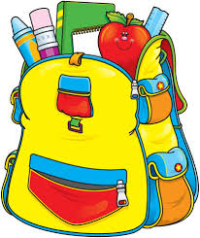
- Pencils
- Pencil case
- Pencil sharpener (WITH lid)
- 3 composition notebooks (Reading, DI, Homework)
- 1 two pocket folder
- Crayons
- Color pencils
- Glue stick
- Construction paper
- Scissors
- Red pens
- Headphones
Class Donations (Optional):
- Copy paper (white and/or colored)
- Hand sanitizer
- Wet wipes

